LBS College Management Database

Sironj Pin Code- 464228, Dist. Vidisha ,Madhya Pradesh

Affiliation From Barkatullah University Bhopal



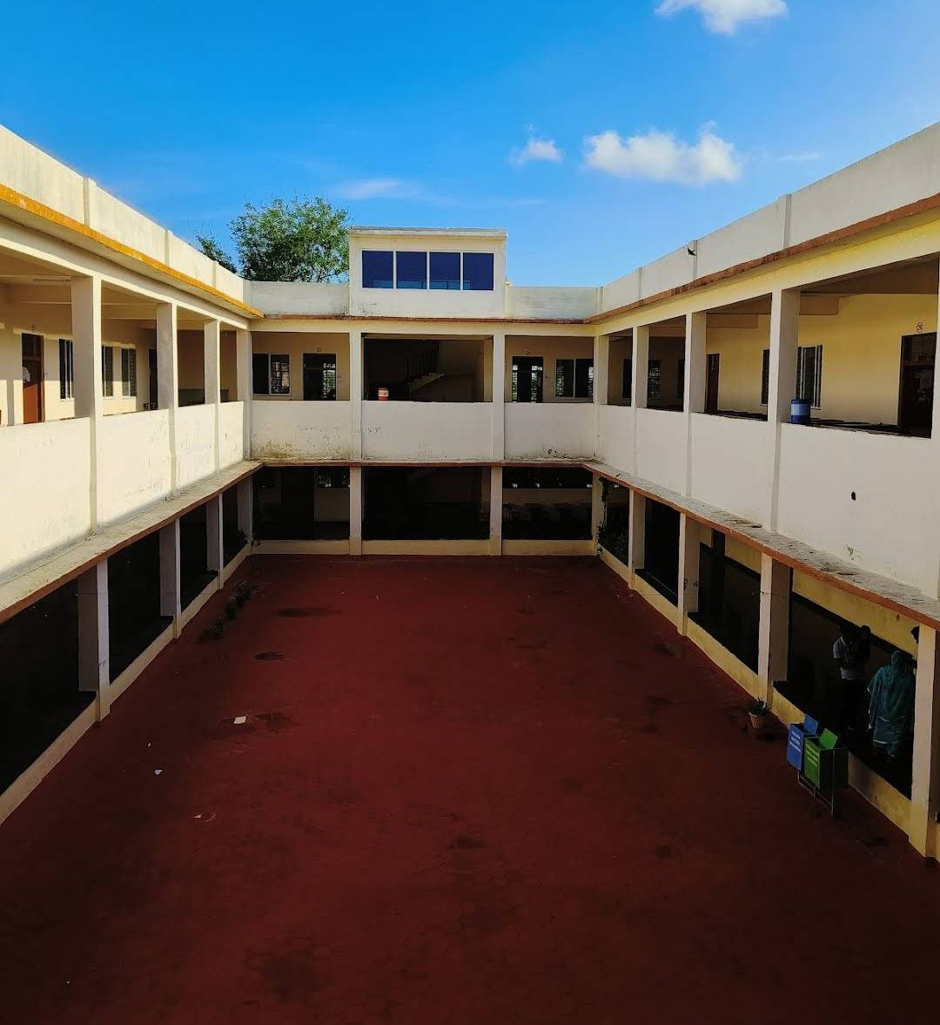

Introduction

:-Document Purpose

:-Project Background

:-Aim and Objectives

:-Working of the Business/Management

:-Functional Requirements Overview

:-Student Module

:-Courses Module

:-Faculty Module

:-List of Figures:

:-Entity Relationship Diagram

:

Document Purpose:

The purpose of this document is to provide a comprehensive overview of the college management system project for LBS College Sironj. It outlines the objectives, functionalities, and structure of the system, aiming to guide stakeholders through the development and implementation process.

Project Background:

In today's digital age, educational institutions face increasing challenges in managing administrative tasks efficiently. Traditional methods of course and student management are often time-consuming and prone to errors. Recognizing these challenges, our project aims to develop a college management system that leverages technology to streamline processes and enhance overall efficiency.

Additionaly its very crucial to digitalize rural educational institutions.

Aim and Objectives:

The primary aim of the college management system project is to modernize and optimize the administrative processes within educational institutions. Our objectives include:

Automating course and student management processes to reduce manual effort and minimize errors.

Improving communication and collaboration between faculty, students, and administrative staff.

Enhancing data management capabilities to facilitate informed decision-making and analysis.

Providing a user-friendly interface that is accessible to all stakeholders, including faculty, students, and administrators.

Working of the Business/Management:

The college management system serves as the backbone of administrative operations within the educational institution, facilitating efficient management of various processes. At its core, the system operates as a centralized database that stores and organizes data related to departments, courses, subjects, faculty, students, and exams.

One of the key functionalities of the system is its ability to streamline course and student management processes. Through the system, administrators can easily create and manage courses, specify course details such as duration and number of students, and assign subjects to each course. This centralized approach to course management eliminates redundancies and inconsistencies often associated with manual record-keeping methods.

Additionally, the system provides robust tools for student management, allowing for seamless registration, enrollment, and academic tracking. Students can register for courses, update their personal information, and view their course schedules and academic progress through the system's user-friendly interface. This empowers students to take control of their academic journey and stay informed about their educational pursuits.

Functional Requirements Overview:

Student Module:

The student module provides functionalities for student registration, profile management, course enrollment, and access to exam schedules and results. Students can easily register for courses, update their personal information, view their course schedules, and track their academic progress through the system.

Courses Module:

The courses module enables faculty and administrators to create and manage courses offered by the college. It includes functionalities for course creation, subject management, enrollment management, and course scheduling. Faculty can create new courses, add or modify subjects, manage student enrollments, and schedule exams through this module.

Faculty Module:

The faculty module serves as a comprehensive tool for faculty members to manage their teaching assignments, course activities, and exam responsibilities. It includes functionalities for profile management, course management, and exam management. Faculty members can update their personal information, view course details, assign subjects, input grades, and generate exam reports using this module.

This presentation provides an in-depth exploration of the college management system project, highlighting its objectives, functionalities, and potential impact on the educational instituti

ENTITY Relationship Diagram

Date

Subject

Department

Name

Salary

ID

Sub_id

Sub_Name

Conducts

Department

Ag

DOB

Phone_no

Name

Duration

Course Id

Pin Code

City

St. Id

Name

Takes

Belongs

Subject

handles

Enrols

Faculty

Teachers

Course

Student

Exam

Address